**ClotheUp**

**Clothing Recommendation Website**

**MINOR PROJECT II**

Submitted by:

**Ayushman Mittal (9914103223)**

**Satyam Mongia (9914103228)**

**Vaibhav Sharma (9914103239)**

**Yash Joshi (9914103252)**

Under the supervision of:

**Mr. Himanshu Mittal**



**Department of CSE/IT**

**Jaypee Institute of Information Technology University, Noida**

# May 2017

**ACKNOWLEDGEMENT**

We express our sincere gratitude to Mr. Himanshu Mittal,Dept. of Computer Science, Jaypee Institute of Information Technology, Noida, India, for his stimulating guidance, continuous encouragement, useful suggestions and supervision throughout the course of present work.

We also wish to extend our thanks to our other classmates for their insightful comments and constructive suggestions to improve the quality of this project work.

**Signature(s) of Students**

Ayushman Mittal (9914103223)

Satyam Mongia (9914103228)

Vaibhav Sharma (9914103239)

Yash Joshi (9914103252)

*i*

**ABSTRACT**

A Bayesian network is a representation of a joint probability distribution of a set of random variables with a possible mutual causal relationship. The Naive Bayesian classifier is based on Bayes' theorem with independence assumptions between predictors. A Naive Bayesian model is easy to build, with no complicated iterative parameter estimation which makes it particularly useful for very large datasets.

Our project is based on a Naïve Bayes. In our project, we have one interface for the Client. We have constructed a data-set with the help of a survey which has all features that we have posted as questions on our website as tuples such as occasion, budget, climate etc. The data set has four more tuples, in which the people taking the survey have told their favourite clothing (top: shirt, top, blouse; top colour; bottom: pant, jeans, shorts; bottom colour). Using this dataset, we have found out the conditional probabilities of the favourite clothing considering the features.

Then, when a user will visit the website and fill the form containing the same features as questions (except Top, Top Colour, Bottom, Bottom Colour), it is passed to the Naïve Bayes Network. The Network will then compute an output (top, top colour, bottom and bottom colour) using the responses of the user and already recorded/computed conditional probabilities.

Using such architecture or this technique for clothing recommendation is efficient as it recommends clothing to a user based on his/her own surroundings and conditions and other people’s likeliness with almost the same responses as that user. This helps the user to choose a clothing that is in trend right now and also what is best suited for people with the same responses as given by the user.

We have also implemented Decision Tree for our project. But we found out that Naïve Bayes is much more efficient than Decision Tree.

*ii*

**TABLE OF CONTENTS**

Page No.

*Acknowledgementi*

*Abstract ii*

*List of Figures iii*

**Chapter 1: INTRODUCTION**

1.1 What is a Clothing Recommendation Website?1

1.2 What is Naïve Bayes? 1

1.3 About Our Project 1

**Chapter 2: Background Study 2**

**Chapter 3: REQUIREMENTS ANALYSIS 3**

3.1 Software Requirements 3

3.1.1 Apache HTTP Server3

3.1.2 MySQL 3

3.1.3 WAMP/LAMP 3

3.1.4 Web Browser 3

3.2 Hardware Requirements 4

3.2.1 Storage Requirements 4

3.2.2 Memory Requirements 4

3.2.3 Administrator Access 4

3.3 Functional Requirements 4

3.4 Non Functional Requirements 4

3.5 End User Requirements 5

3.6 UML Diagram 6

**Chapter 4: IMPLEMENTATION AND PRESENT WORK 7**

**Chapter 5: DETAILED DESIGN 8**

**Chapter 6: CONCLUSION AND FUTURE SCOPE 9**

**References10**

**LIST OF FIGURES**

**Figure Title Page**

3.6.1 Use Case Diagram .................................. 6

5.1 Detailed Design ....................................... 8

*iii*

1. **INTRODUCTION**
   1. **What is a Clothing Recommendation Website?**

A recommendation website is a platform or an interface which recommends something on the basis of certain inputs or certain beliefs etc.Recommendation websites mostly work on machine learning algorithms. Our website is based on clothing recommendation. The website enables users to fill out the form on the website which asks about their condition (for eg. Season, occasion etc.) and based on those inputs, it gives an output about which Top and Bottom should the person wear and of which colour.

* 1. **What is Naïve Bayes?**

It is a classification technique based on Bayes' Theorem with an assumption of independence among predictors. In simple terms, a NaiveBayes classifier assumes that the presence of a particular feature in a class is unrelated to the presence of any other feature. In Naïve Bayes, we find out conditional probabilities P(X/C) i.e. Probability of X if C is given. This probability is calculated using a mathematical formula.

* 1. **About Our Project**

This project is based on a thought about what would really help the people in the market. Clothes are a very important part of people’s lives. And deciding what to wear is the most difficult task and takes up most of our time. So with this thought, we have created a user-friendly website that solves people’s worry by helping them with their clothing decisions by giving a recommendation. The recommendation given on our website is based on user’s input such as their gender, budget, season, occasion, hair colour, skin tone etc. The recommendation tells the user about the Top, Colour of the Top, Bottom and Colour of the Bottom. If the user doesn’t like the given recommendation, a second option is also provided.

1

1. **BACKGROUND STUDY**

Web pages are built using text-based mark-up languages (HTML and XHTML), and frequently contain a wealth of useful data in text form. However, most web pages are designed for human end-users and not for ease of automated use.

To show outputs based on several inputs and one fixed dataset, there are several algorithms that could be used. Some of them are Naïve Bayes, Decision Tree, Bayesian Network, Artificial Neural Network. From all of these, Naïve Bayes is the easiest and to the point algorithm which predicts the output on the basis of conditional probabilities. Naïve Bayes is a technique based on Bayes’ Theorem but unlike Bayes’ Network, there is independence among the predictors or the inputs.

Naïve Bayes also has better accuracy in less lines of code (LOC) whereas other algorithms such as Decision Tree have lower accuracy and very high lines of code (LOC).

So we thought of creating a website where one can login and fill out a form about some basic questions such as climate and occasion and get a predicted recommendation of clothing. We have implemented this/compared this website by using two algorithms ie. Naïve Bayes and Decision Tree and have shown the results for accuracy.

**2**

1. **REQUIREMENT ANALYSIS**
   1. **Software Requirements**

Our project is an offline project. This project can be accessed by completing the following software requirements:

* + 1. **Apache Server** : The Apache HTTP Server is the world's most used [web server](https://en.wikipedia.org/wiki/Web_server) software. It’s an effort to develop and maintain an open-source HTTP server for modern operating systems including UNIX and Windows. The goal of Apache is to provide a secure, efficient and extensible server that provides HTTP services in sync with the current HTTP standards.
    2. **MySQL**: MySQL is an open-source relational database management system (RDBMS).MySQL compiles on a number of platforms. MySQL is developed, distributed, and supported by Oracle Corporation. The data in a MySQL database are stored in tables.A table is a collection of related data, and it consists of columns and rows.
    3. **WAMP/LAMP**: WAMP and LAMP are software stacks for softwares Window/Linux, Apache HTTP Server, MySQL, PHP. It basically is a software that works on an OS (W or L) and provides Apache, MySQL and PHP.
    4. **Web Browser**: A web browser is a software application for retrieving, presenting and traversing information resources on the World Wide Web. Any available browser can support the project (Google Chrome, Internet Explorer, Mozilla Firefox)

3

* 1. **Hardware Requirements**
     1. **Storage Requirements**: Minimum storage required is 2GB of hard disk space.
     2. **Memory Requirements**:Minimum RAM requirement is 2GB
  2. **Functional Requirements**
     1. **User registration**: New user should be able to register in order to seek recommendation.
     2. **User Preferences/Input Form**: User should be able to fill in the form through which he will get recommendation.
     3. **View Recommendation**: Users must be able to view the recommended top, top colour, bottom and bottom colour after he fills the form.
     4. **View Previous Recommendations**: Users must be able to view their previously recorded inputs and previous recommendations.
  3. **Non Functional Requirements**
     1. **Validation in the forms**

All the forms are validated using PHP.

* + 1. **Usability**

This website is made very easy and understandable for all kinds of users.

* + 1. **Simplicity**

This site is particularly made for the normal, non-technical users so the website is very simple to use and user-friendly.

* + 1. **Security**

All data is secure. Passwords are encrypted and all user data is secure.

4

## **End User Requirements**

* End user should be able to access the website from any web browser (Google Chrome, Internet Explorer, Mozilla Firefox)
* User must be able to register and login on the website.
* User must be able to fill the form to get recommendation on the website.
* User must be able to see what the site recommends to him/her based on the inputs given by the user.
* User must be able to see a second option of recommendation if he/she is not satisfied with the first result.
* User must be able to view his previous recommendations and the inputs corresponding to those recommendations.

5

* 1. **UML Diagram**
     1. **Use Case Diagram**

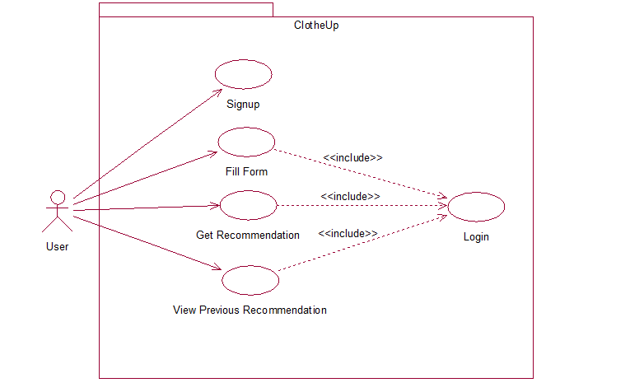

6

* + 1. **Activity Diagram**



1. **IMPLEMENTATION AND PRESENT WORK**

We have implemented our project in the following manner:

First of all, we started with the Frontend of the Website. We started working on the frontend in HTML and CSS language.Hypertext Markup Language [**HTML**], a standardized system for tagging text files to achieve font, colour, graphic, and hyperlink effects on World Wide Web pages.Cascading Style Sheets [**CSS**] is a style sheet language used for describing the presentation of a document written in a markup language.We then did a survey through google form (<https://goo.gl/forms/MsOcicfc8JE8UAhu1)> to form our database in which we asked people about what they would like to wear in a particular climate, occasion, budget etc.

Then after the survey, we made a database using MySQL.

We created tables in MySQL one by one according to our need.

We then linked the database to the front-end of the project through PHP.**PHP** is a general-purpose scripting language that is especially suited to server-side web development, in which case PHP generally runs on a web server. Any PHP code in a requested file is executed by the PHP runtime, usually to create dynamic web page content or dynamic images used on websites or elsewhere.

Then finally, we implemented two algorithms namely Naïve Bayes and Decision Tree to show the output/prediction/recommendation.

**FORMULAS USED:**

**Naïve Bayes:**

**P(X/C)** = SUMMATION [ P(C/X) * P(X) ]

**Decision Tree:**

**Entropy(S)** = -p+ log2 p+ - p- log2 p-

**Gain(S, A)** = Entropy(S) – summation((mod (Sv) /mod (S) * Entropy(Sv))

7

1. **DETAILED DESIGN**

**SURVEY**

**CLIENT INTERFACE**

**DATASET**

**INPUTS**

**NAÏVE BAYES CLASSIFIER**

**BOTTOM COLOUR**

**BOTTOM**

**TOP**

**TOP COLOUR**

8

1. **CONCLUSION AND FUTURE SCOPE**

This website seeks to build a platform where people can get clothing recommendation. This life saving website helps people to do the perfect clothing and not worry about what to wear and when to wear. The user just has to fill out a simple form and get a recommendation within seconds.

As shown, the accuracy for the Naïve Bayes implementation is higher than the Decision Tree implementation, we further seek to expand our website using Naïve Bayes and Bayesian Network for future work. We also seek to add a user feedback option. And after getting some responses from people about how to make our website better, we also wish to add more features and predict better and precise clothing.

9

**REFERENCES:**

**Book**

# [1] Machine learning : By Tom Mitchell, 1997

# Online:

[2]<http://www.tutorialspoint.com>

[3] <http://www.stackoverflow.com>

[4] <http://www.w3schools.com>

[5] <http://www.wikipedia.com>

**Proceedings paper**

[6] Lin Yu-Chu, Yuusuke Kawakita, Etsuko Suzuki *“Personalized Clothing-Recommendation System based on a Modified Bayesian Network”* Department of Informatics University of Electro-Communications, Tokyo, Japan

[7] Michal Horny “*Bayesian Network*” Boston University School Of Public Health

10

**DATABASE AND TABLES USED**

**Database name**: ‘**clotheup**’

**No. Of Tables: 5**

**Names of the tables:**

1. **dataset**
2. **login**
3. **user_input**
4. **smalldataset**
5. **testingdataset**

**ACCURACY TESTING RESULTS**

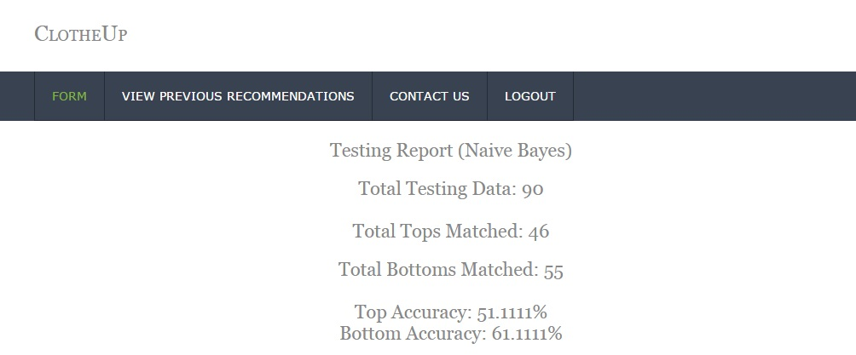



**The accuracy for Naïve Bayes is better than that of Decision Tree for both Top and Bottom.**

**Therefore, Naïve Bayes is a better algorithm for our work and our dataset.**